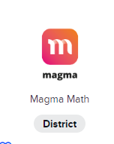**How To Assign Practice in Magma Math**

Log in to Magma Math through Clever

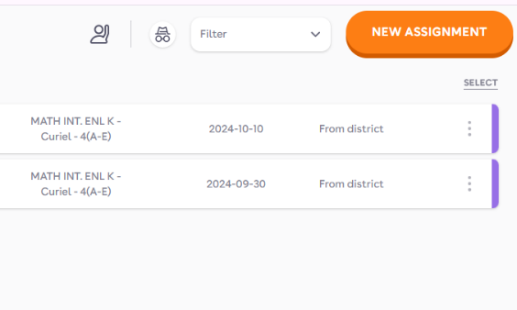

Press new assignment in the top corner

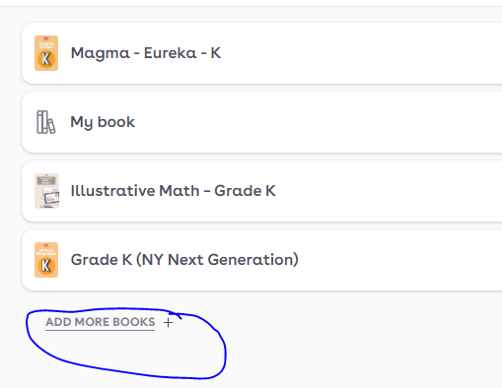

Press add more books and add

-Illustrative Math- Grade K

-Grade K (NY Next Generation)

This will allow you to seach by

Standard.

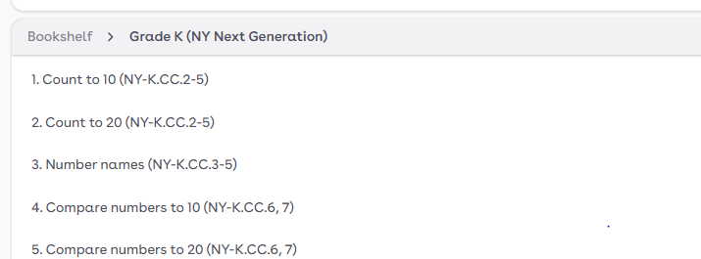

Select the topic/ standard

Create the assessment.

Select the exact questions in the box that you would like on the assessment.

Click the box. (do not check off mild/medium/spicy on top or it will assign all of the questions)

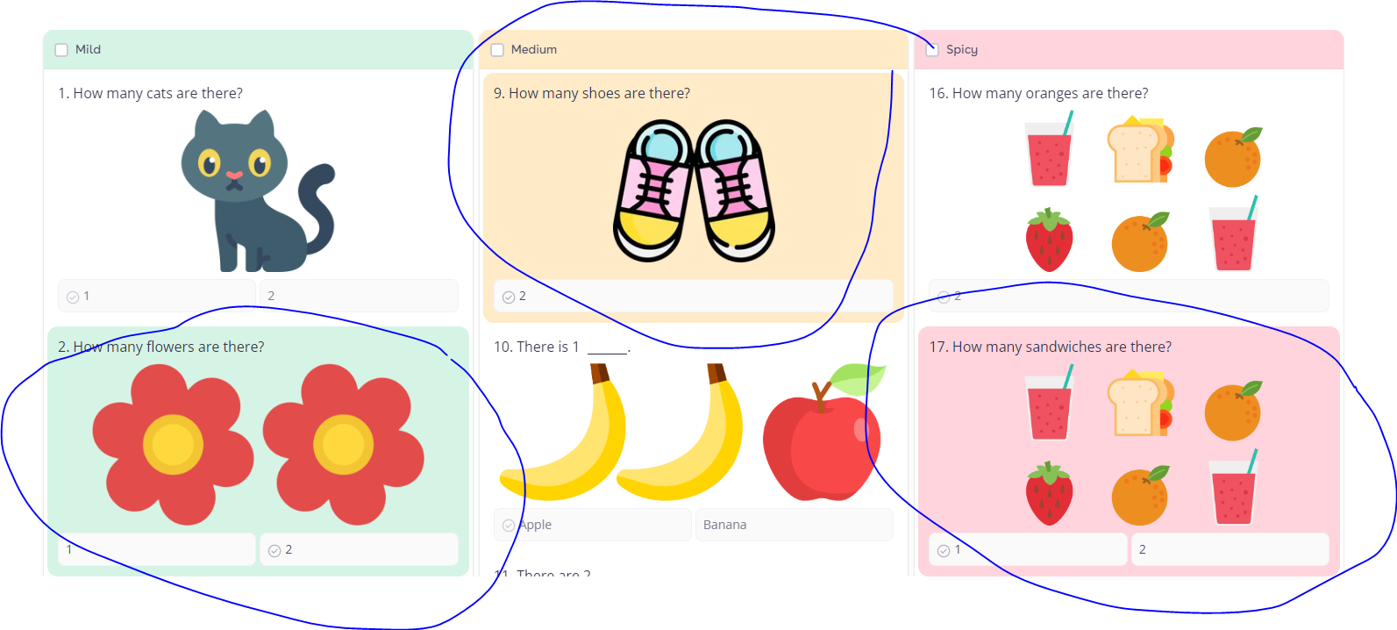

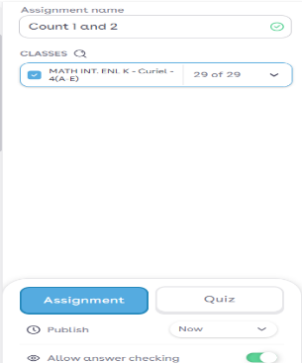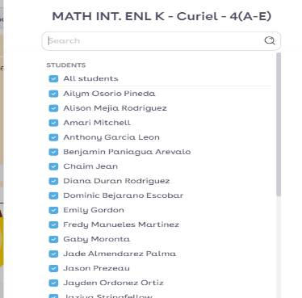

Assign it to a class

Press the arrow to see the list of students

If you want all students to receive the assignment

Select ALL STUDENTS

If you want specific students just check off their names.

Press save



Press create

You will find the Assignment on your assignments screen.

To edit press the 3 dots and edit.

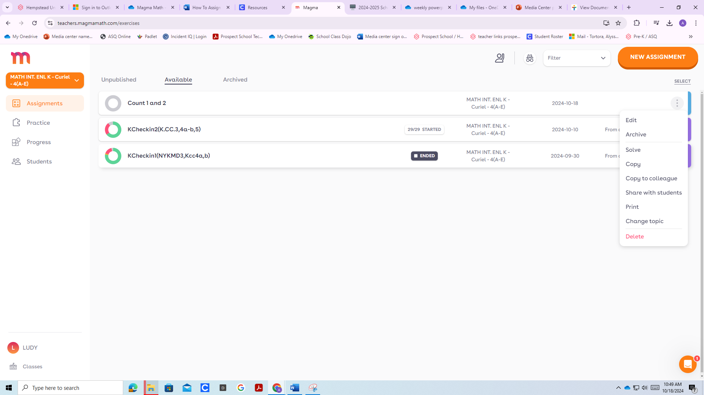

Video directions: <https://www.youtube.com/watch?v=33p3ZEn4mmA>

[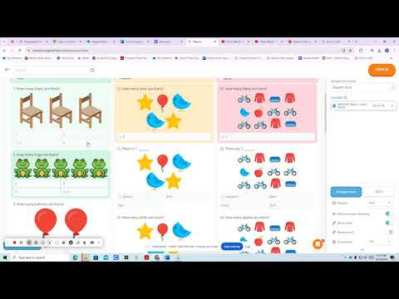](https://www.youtube.com/watch?v=33p3ZEn4mmA)